Systems Engineering Handout

Prepared by: Kirtan Patel (s2935848), Sally Mohamed (s2273144)

PSE Group 2 | ME Module 11: Production Systems Engineering

Faculty of Engineering Technology | University of Twente

# 1. Stakeholder Analysis

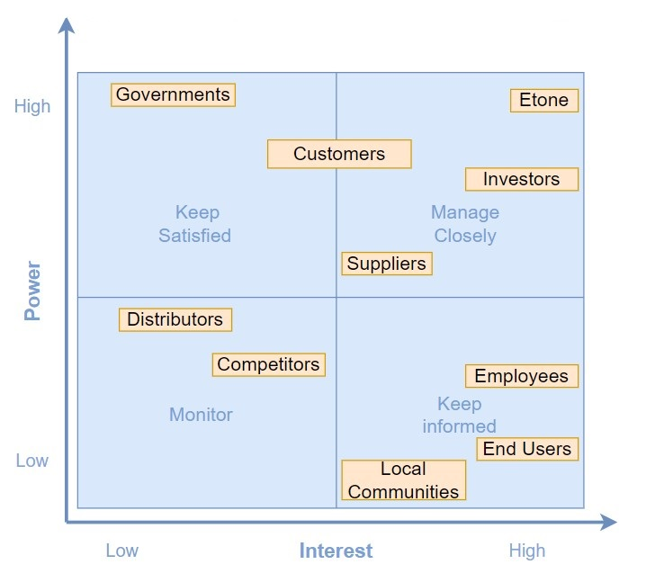



After performing the stakeholder analysis, several process key drivers have been established to each stakeholder in order to map their requirements as can be seen in figure 2. The Employees, End Users and Local Communities were excluded from this diagram since their requirements of sustainability and safety are already set by the government so no additional key drivers have been set for them. Etone needs to make sure that their distributors are reliable and it was assumed that products are delivered right away so they were also excluded. Additionally, Etone only needs to monitor their competitors so they have also been excluded from the key driver- stakeholder mapping diagram as well.

# 2. Key Driver - Stakeholder Mapping

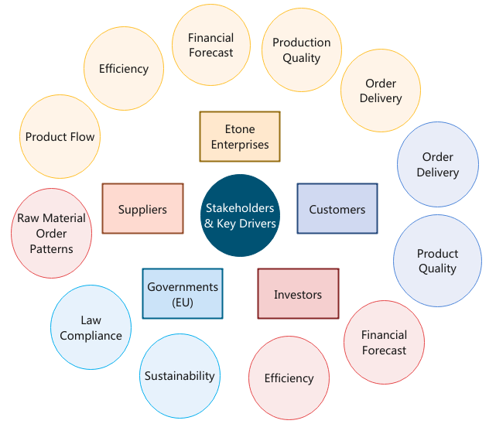

For each stakeholder, the most important system parameters were identified as key drivers and for each key driver, several functional requirements have been identified as can be seen in the poster. Additionally, general non functional requirements have also been determined for the systems in order to quantify the general functionality of the entire production system.

# 3. FunKey Coupling Matrix

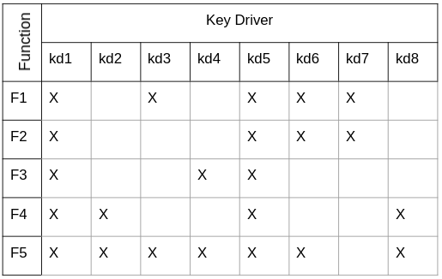



kd1 : Raw Material Order Pattern

kd2 : Product Flow

kd3 : Efficiency

kd4 : Financial Forecast

kd5 : Product & Production Quality

kd6 : Order Delivery

kd7 : FEM Analysis

kd8 : Legality & Sustainability

F1 : Sequence & Schedule Production

F2 : Manage Inventory

F3 : Monitor Finance

F4 : Generate Layout

F5 : Monitor Production

# 

# 4. Subsystems Explained

# **Production Planning & Control (PP&C)**

Schedule production including predicted maintenance time based on the data in the excel. Production Schedule includes production sequence for the delivery of the end product. They take into account the startup defects as well. This is the planning part.

They get input from QC&RM about the preventive and corrective protocol and implement that in the production schedule when there are defects creating an adjusted schedule. This is the control part. The control part consequently affects the finance and inventory part.

# 

# **Finance & Inventory Management (F&IM)**

They receive the production schedule from PP&C as well as land requirement from PF&D. They create a list of raw materials, new machines and staff needed as well as new floor space and use that for cost prediction as well as Inventory Management and warehousing. They determine when material orders should be placed and how much is needed.

**Production Flow & Design (PF&D)**

They receive information about the production schedule and sequence from PP&C and warehousing information from F&IM in order to create the optimum floor plan layout so that interdependent machines are grouped in order to minimize the ide time while keeping in mind the safety of the floorplan layout and keeping enough space for inventory. This is their initial role. Their continuous role is monitoring the product flow between the different production steps and ensuring that the unfinished product batches are moved to the correct stations on time so that the finished product can be completed in time to meet the delivery schedules.

# **Quality Control & Risk Mitigation (QC&RM)**

They receive the inputs from the different subsystems and do a risk and FMEA analysis. They maintain quality control based on statistical models by deriving a preventative and corrective protocol (including maintenance strategy) in case failure occurs during production. They present the FEM analysis of the cranes since this can be seen as a risk preventative method for ensuring the end product quality is met.

The preventative protocol from QC&RM is given to the different subsystems again so that they can reimplement it in their subsystems. This mainly concerns PP&C and F&IM so they redesign the production schedule and inventory by implementing the maintenance strategy and keeping a safety stock in the warehouse in order to lower the risk of inactive operations.

# 5. Subsystem-KPI Mapping

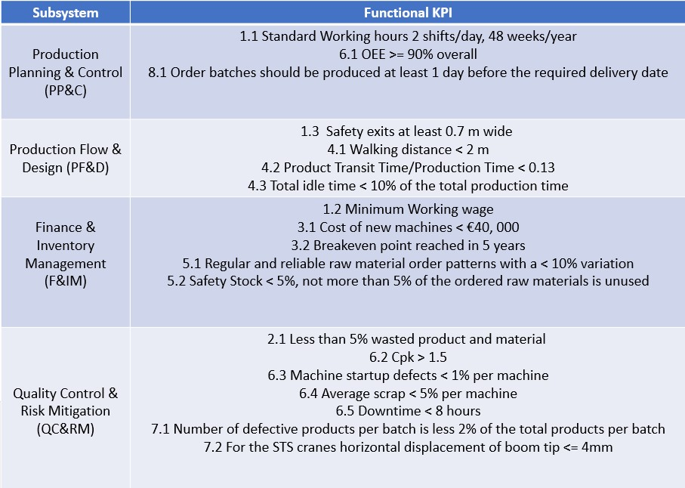

# 

# 

# 

# 

# 

# 6. Subsystem Test Description

There are 19 Functional KPIs and 5 nonfunctional KPIs which were defined for our Production system. The functional KPIs have been defined to each subsystem while the nonfunctional KPIs deal with the overall functionality and integration of the production system. To verify and validate that the production system meets the defined system requirements we carry out unit testing as well as integration testing. Therefore, two test protocols have been defined where protocol (1) tests the subsystems separate functionality according to the functional requirements while protocol (2) tests that the interaction between the subsystems are efficiently carried out leading to the fulfillment of the nonfunctional requirements. The test protocol descriptions are outlined below.

**Test Protocol 1: Unit Testing**

The protocol consists of multiple tests where each test consists of subtests that concern a functional KPI. The KPIs are stated with the numbers defined in table 2 in bold followed by the suitable test description.

*Test 1: Documentation Inspection*

*Test 1.1:* [for requirement **1.1**] The working hours of the machines and workers should be documented and should not exceed the standard period. Monthly checkups of these documentations should be made.

*Test 1.2:* [for requirements **1.2**, **3.1** and **3.2**] The financial books should be inspected in order to ensure that minimum wages are paid and that the breakeven period can be reached within 5 years by comparing the revenues and expenses and doing the necessary adjustments.

*Test 1.3:* [for requirement **5.1**] The customer demand should be forecasted, and the raw material orders should be planned accordingly. Since the annual customer demand is known by Etone, the raw material order patterns should be reliable and should not have high fluctuations. This is documented and checked and should be ensured by proper production planning.

*Test 2: Floor Inspection*

*Test 2.1:* [for requirements **1.3** and **4.1**] The floorspace will be inspected before the start of production to make sure that the layout meets the requirements and matches the blueprints of the factory.

*Test 2.2:* [for requirement **8.1**] Finished orders should be reported and the order progress should be checked regularly to make sure that it is completed within the specified time

*Test 2.3:* [for requirement **5.2**] The amount of stock left in the warehouse at the end of the month should be calculated and compared to the amount of the raw materials ordered. If this is more than 5%, this should be reported, and the order patterns should be adjusted.

*Test 3: Efficiency Check*

*Test 3.1:* [for requirements **4.2**, **4.3**, **6.1** and **6.2**] The total production time should be estimated taking into account the amount of rework that needs to be done and machine idle time. The machines should be arranged and grouped in a way that minimizes the walking distance between the machines and product idle time so that the partly finished products can be moved to the next station as soon as possible. Several iterations and layouts can be made to ensure that this is achieved. This is theoretically tested before the start of production and planning of the factory layout. It is then confirmed during production by keeping track of the effective production time and performing the necessary adjustments.

*Test 4: Quality Check*

*Test 4.1:* [for requirement **6.3** And **6.4**] Average scrap per machine and machine startup defects should be calculated after each week and should be less than the values mentioned by the manufacturer. If they exceed these values, maintenance should be performed, or the machine should be replaced.

*Test 4.2*: [for requirement **6.5**] A comprehensive maintenance protocol should be written, and regular machine checkup should be made every 2 months so that the downtime is reduced.

*Test 4.3:* [for requirement **7.1**] Five random parts from each completed batch should be visually inspected for any defects and the dimensions should be measured. If the parts are defective this batch should be reproduced.

*Test 4.4:* [for requirement**7.2**] A crane should be tested with maximum load after assembly and the actual horizontal deflection should be measured to ensure that it is less than 4mm.

*Test 5: Waste Check*

*Test 5.1:* [for requirement **2.1**] The scrap rate and number of defective parts from the quality check test should be reported. This is checked every 2 months in order to ensure that it is kept to a minimum.

**Test Protocol 2: Integration Testing**

The production system can be simulated by creating a virtual test environment similar to the actual production environment. The outputs and inputs of each subsystem should be clearly defined and multiple iterations can be made using different scenarios by altering the parameters of the system to ensure that the relations between the subsystems are efficiently defined and that failures are minimized by minimizing the subsystem interdependencies. This is done before implementing the production system in real life. After the production system is implemented, the subsystems interactions should be carefully monitored and any errors or delays should be reported to the system engineers so that the necessary role re-definitions can be made in order to ensure that the production system is efficient, reliable, flexible, maintainable and cost effective.